# ASSIGNMENT-1

NAME - PRAFULLA CHANDRA

SECTION - CSE-29

ROLL NO. - 21053354

SUBJECT CODE - IT_2095

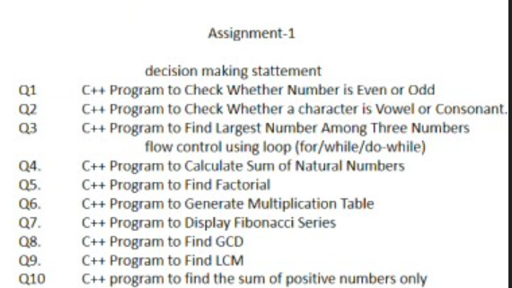

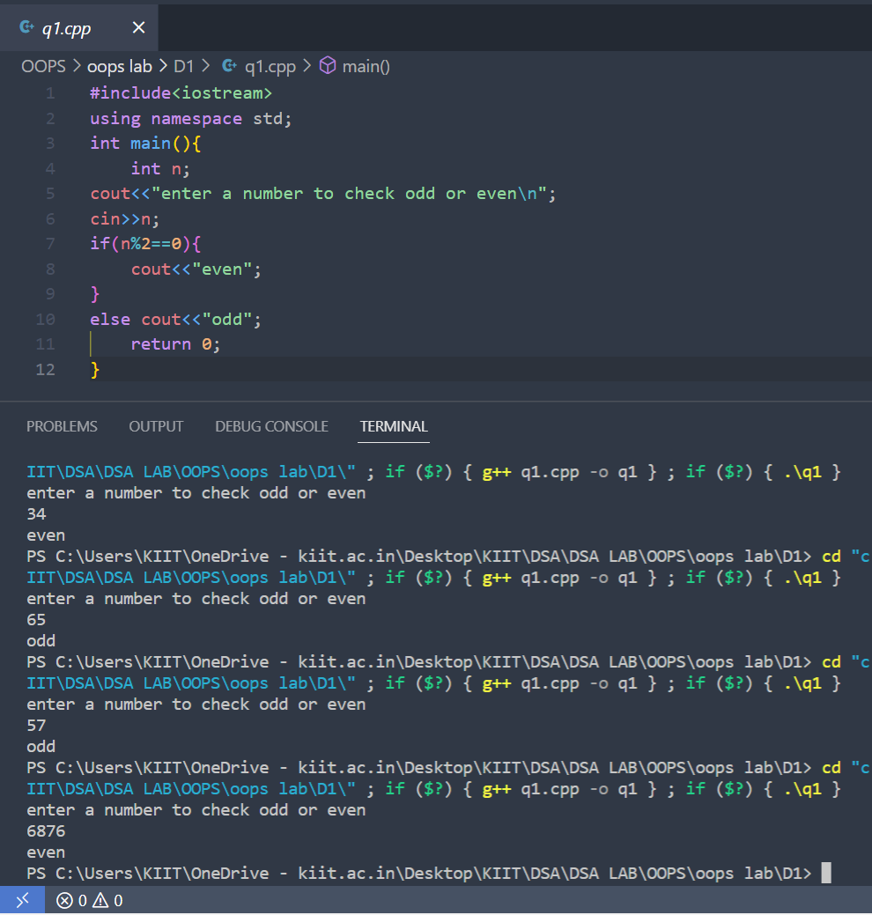

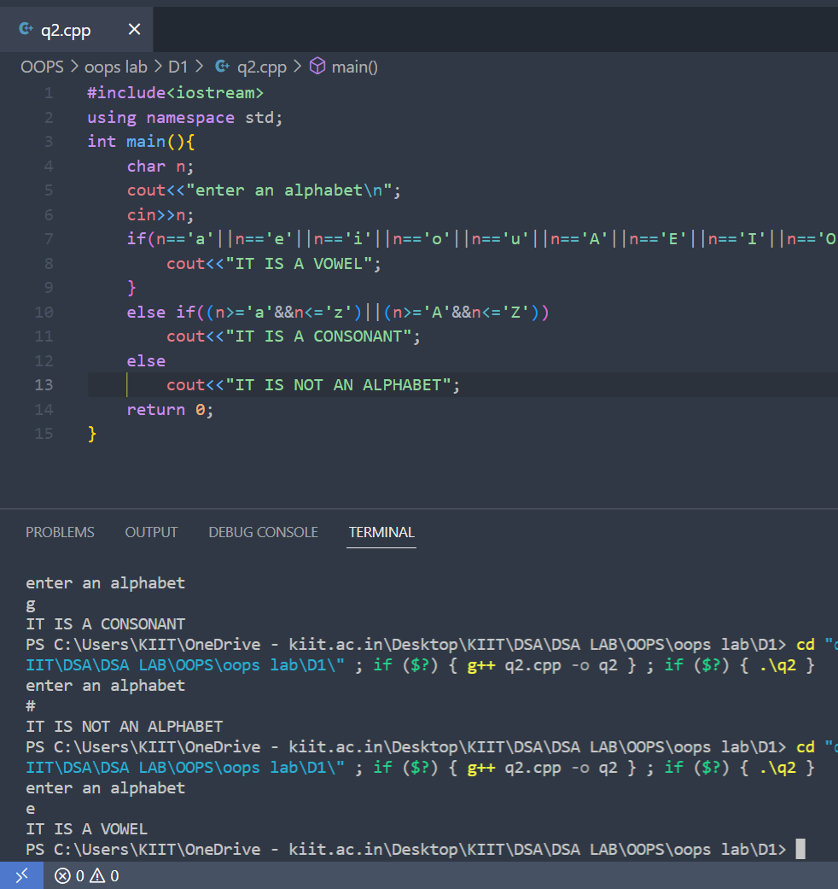

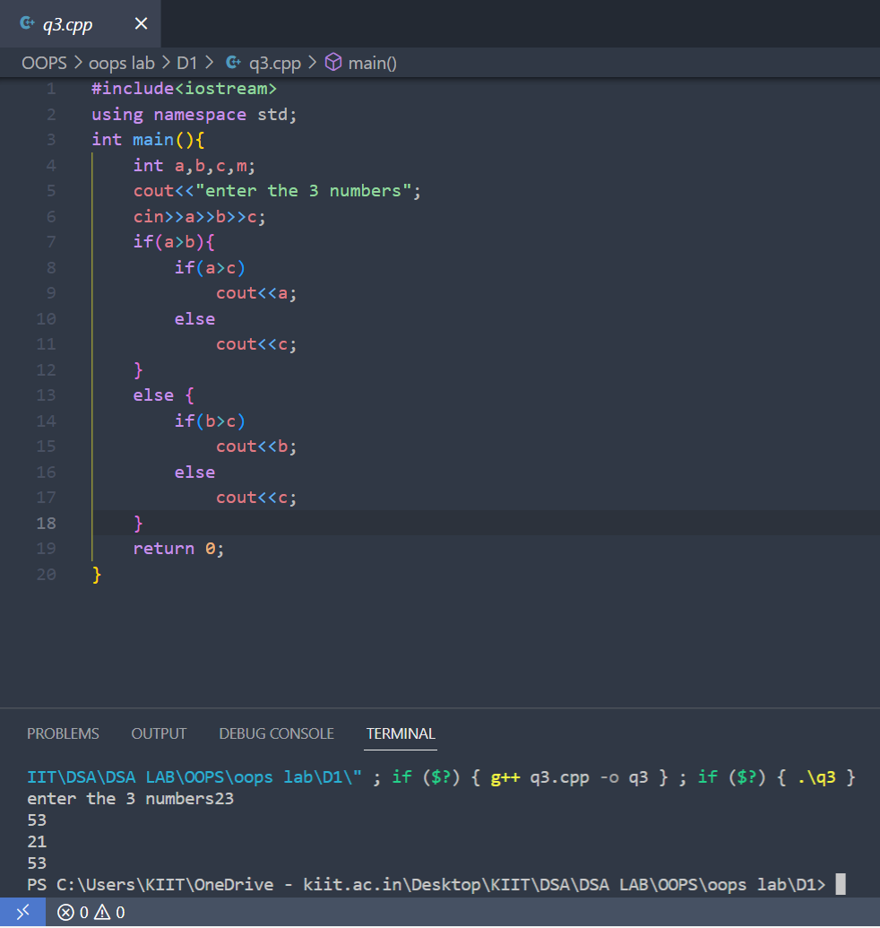

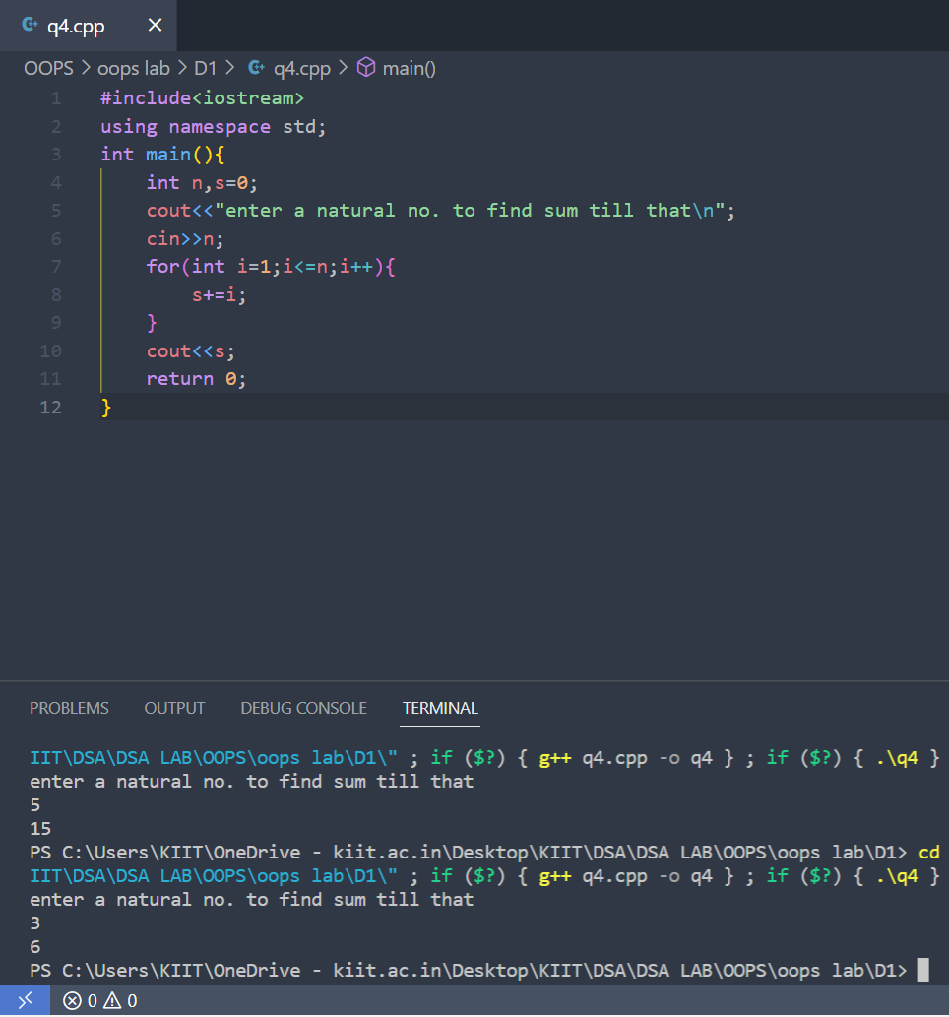

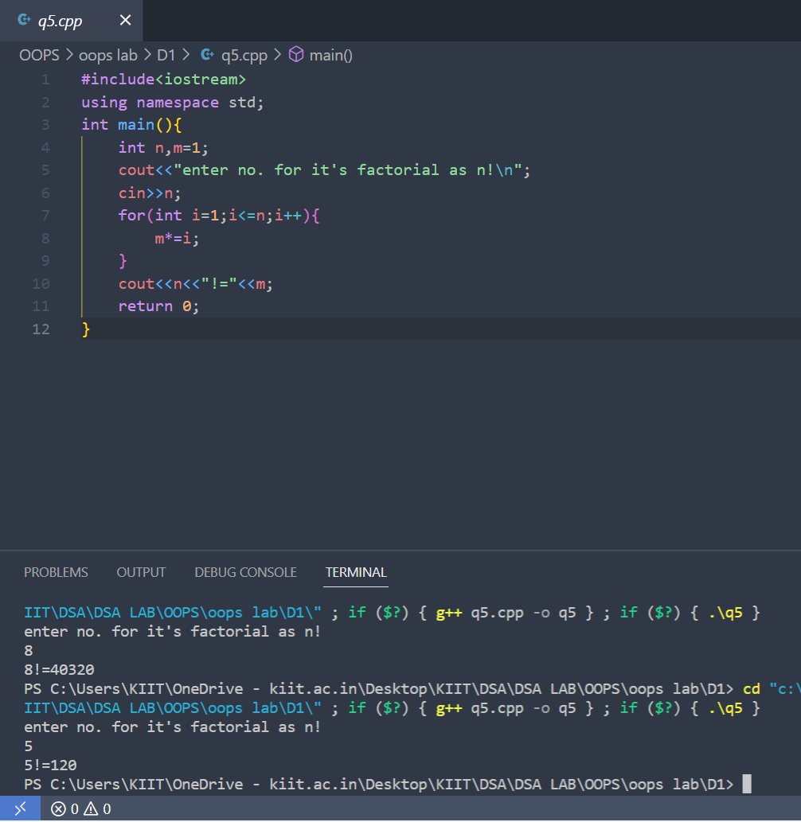

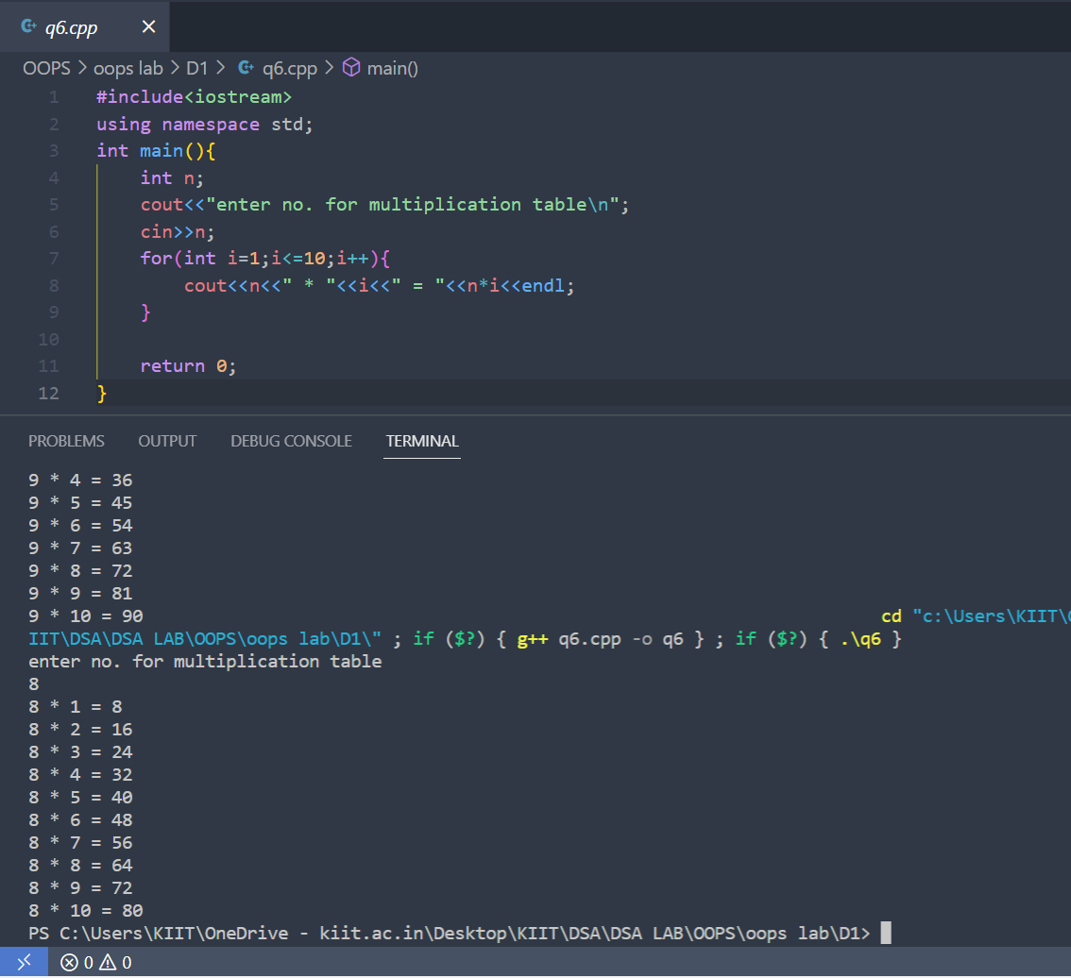

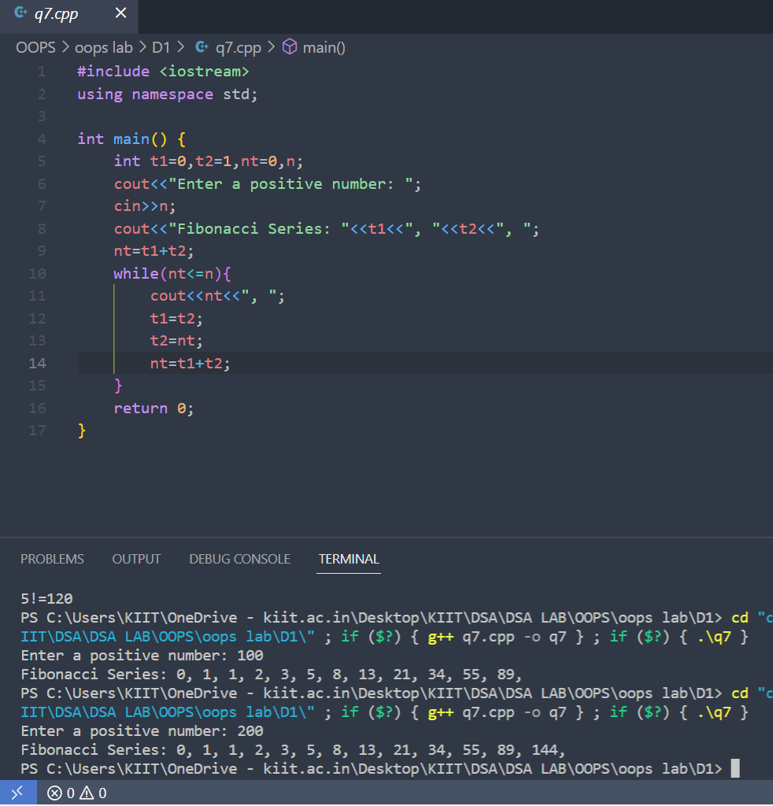

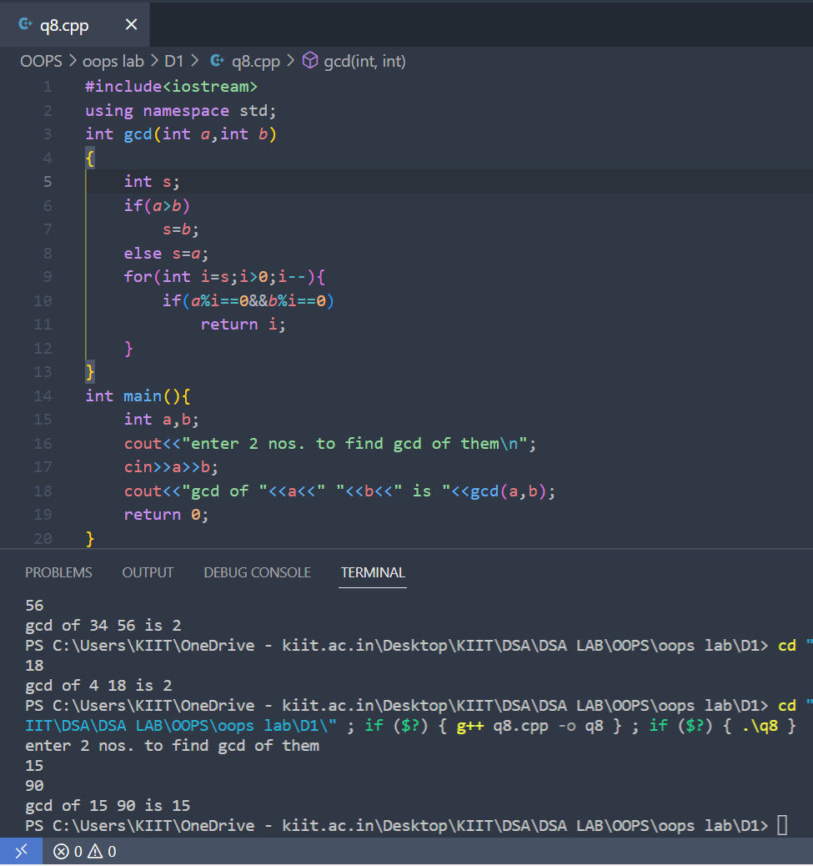

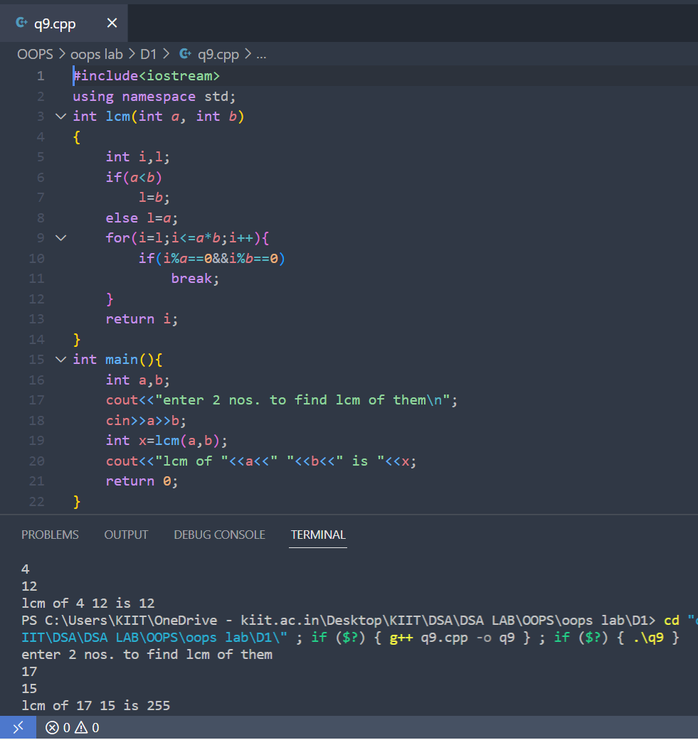

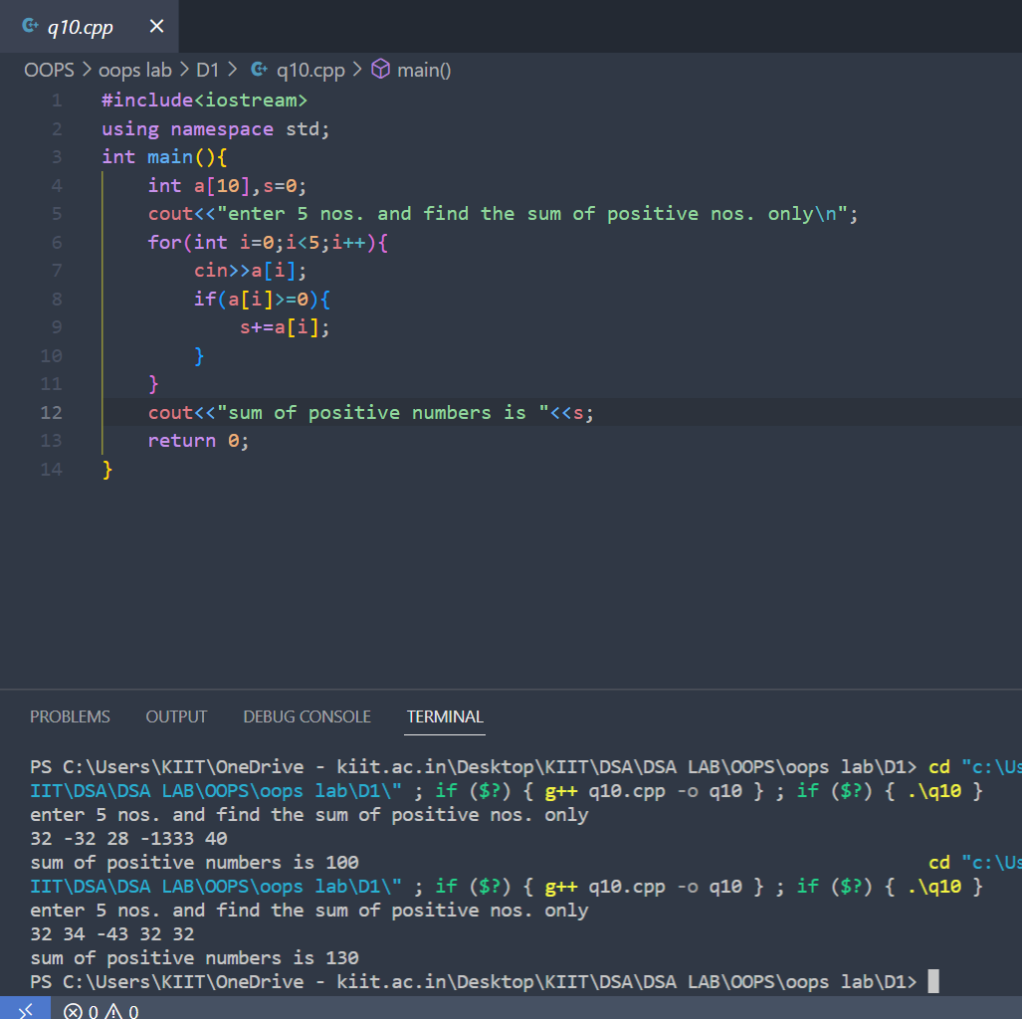

# ASSIGNMENT-2

NAME - PRAFULLA CHANDRA

SECTION - CSE-29

ROLL NO. - 21053354

SUBJECT CODE - IT_2095

**c++ program using function**

**Q1. C++ program to swap two number using function**

**Q2. C++ Program to Display Prime Numbers Between Two Intervals Using Functions**

**Q3. C++ program to Calculate Factorial of a Number Using Recursion**

**Q4. C++ Program to Convert Binary Number to Decimal and vice-versa using function**

**C++ program using 1D and 2D Array**

**Q5. C++ Program to Calculate Average of Numbers Using Arrays**

**Q6. C++ program to Find the largest three elements in an array**

**Q7. C++ program to find the second smallest elements in a given array of integers.**

**Q8. C++ program to find the most occurring element in an array of integers**

**Q9. C++ Program to Multiply two Matrices by Passing Matrix to Function**

**Q10. C++ Program to Find Transpose of a Matrix**

